Web-Client Demo  
User’s manual

Live demo: <https://www.test.tgralex.net/>

Once you enter the site you will see following screen:

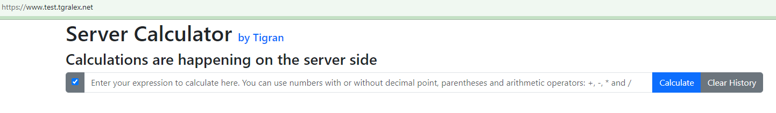

Please note that all buttons and controls on the screen display a tooltip explaining their functionality when you hover over them with the mouse pointer, like this:  
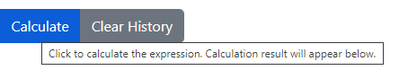

How to use it

1. Enter any arithmetic expression in the edit area. You may include numbers (with or without decimal points), parentheses, and the arithmetic operators: **+** (addition), **-** (subtraction), **\*** (multiplication), and **/** (division).  
   For example: (10 + 5) * 10 / (45 + (1 + 4))
2. Click Calculate button
3. Observe the result. The outcome will depend on the validity of your expression and may be either successful or unsuccessful:   
   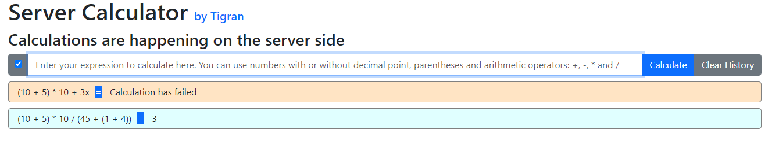
4. The expression must not be empty; otherwise, you will see an error displayed in the bottom-right area of the screen:  
   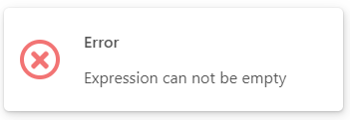
5. The checkbox on the far-left determines whether the expression will be cleared after calculation. By default, it is set to clear. Click the checkbox to toggle this option.
6. When the expression input is cleared, you can select a previously entered value from the dropdown list. This list is preloaded with both valid and invalid expressions for testing purposes:  
   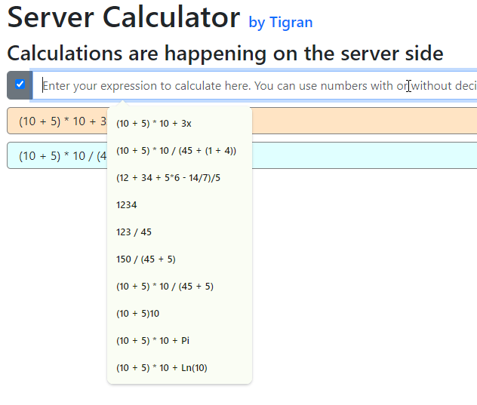
7. You can click on a previously executed expression to reuse it. This action will copy the expression into the current input box:  
   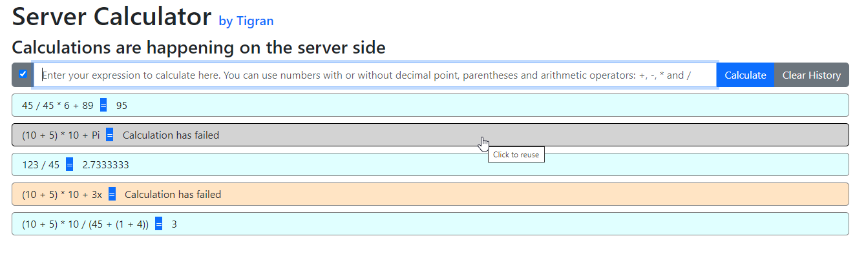
8. Finally, clicking the Clear History button will erase all history as well as the contents of the input box.

All calculations are processed on the server. You can observe these calls in the browser's debug tool under the Network section, which is accessible by pressing F12:  
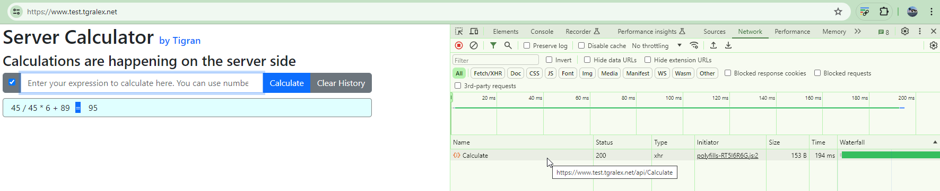

# Testing a Web Client without servers API.

Click on the “Calculations are happening on the server side” label. Once clicked, the label changes to “Calculations are faked” and all API calls will simulate receiving a result from the server:

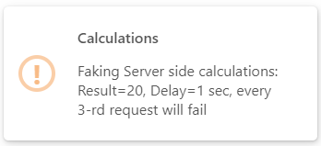

You can verify in the “Network” section of the developer tools that no API calls are being made.   
All results are simulated, not actually calculated. They will either be set to 20 or fail (every third call will fail), with one second delay added to emulate network latency.

Click again on the “Calculations are happening on the server side” label restore server-side calculation functionality:

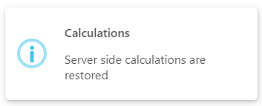

Security measures are integrated into both the client and the backend API

1. Please note HTTPS protocol:  
   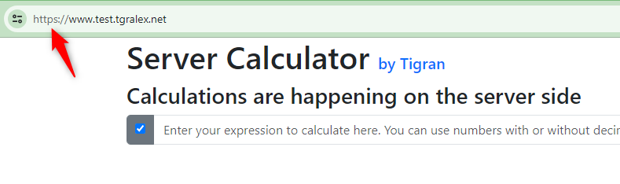
2. I have implemented DDoS protection by setting a Rate Limit on API calls. The policy allows no more than one API call per IP address. To test this, uncheck the Clear Expression After Calculation box, enter a valid expression, and rapidly click the Calculate button several times. You will observe the effect of this policy as shown below:

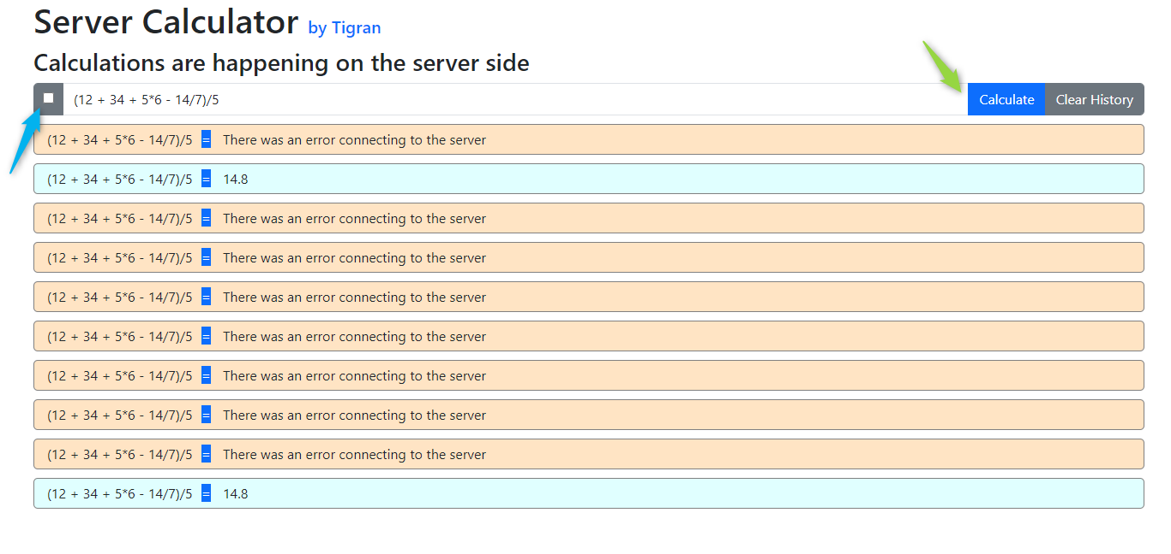

# Asynchronous execution

When you click on the Calculate button, you may notice that a spinner appears while the API call is in progress. The spinner remains visible until a response is received, at which point it changes to a success or error color and displays the result. To see evidence of asynchronous execution, switch to Fake Calculations mode (to introduce a noticeable execution delay). Then, enter any expression, uncheck Clear Expression After Calculation, and rapidly click the Calculate button multiple times. You will observe the following behavior

You will observe following:  
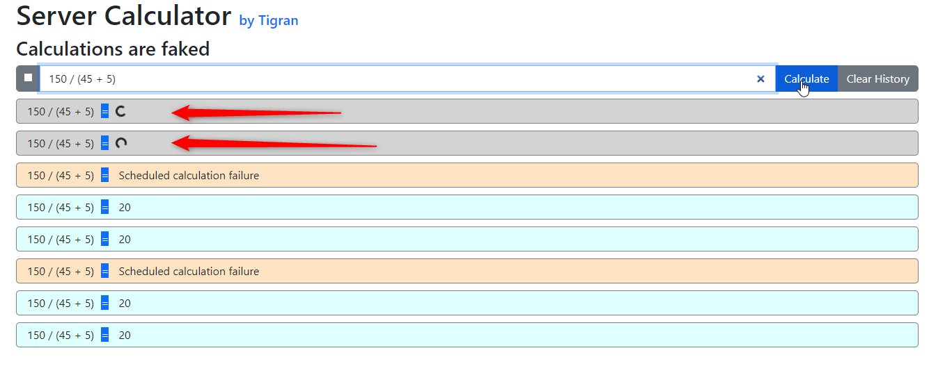

I was only able to capture a couple of parallel executions in the image, but you can observe many more when you try it yourself.

# Server API stand-alone testing

I tested the server API using Postman since it's not possible to test a POST call directly in a browser.   
Below is a screenshot of a successful call.:  
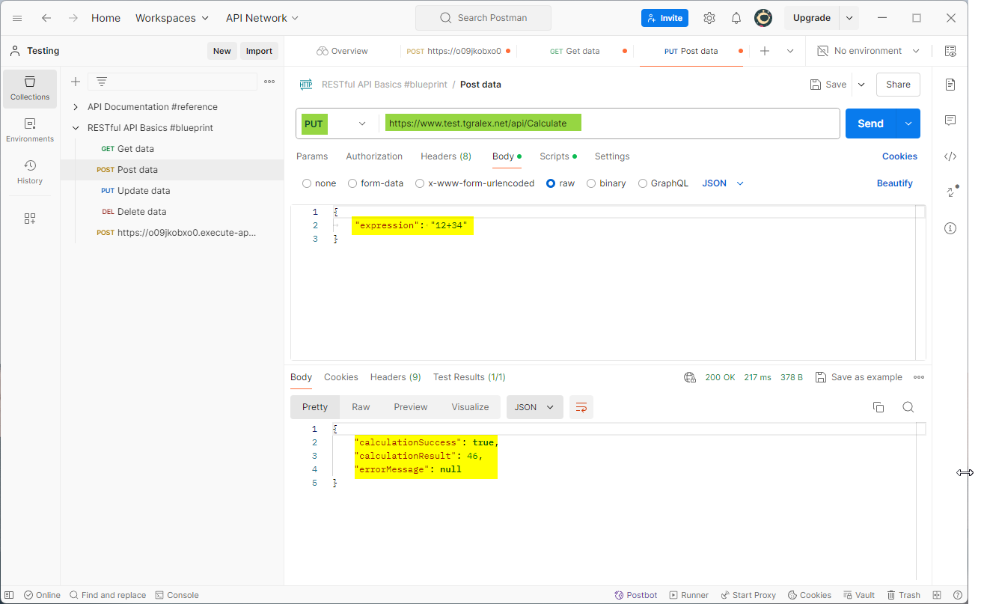

And unsuccessful call due to exceeding the maximum allowed number of requests:  
